# Connecting to VMs using VS Code

1. Launch VS Code (hits the Windows key and start typing “code”; by the time you get to “cod”, you should be able to choose **Visual Studio Code**.
2. Click on Extensions: 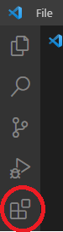
3. In the search box, start typing “Remote” and then **install** the “Remote – SSH” extension: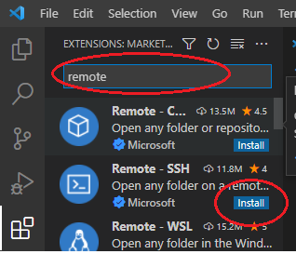
4. Click on the “Remote Explorer” and then the settings button (the “Gear Icon”):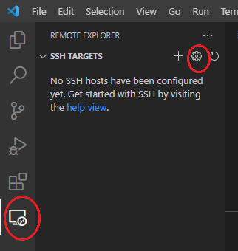
5. In the dialog, choose the default filename: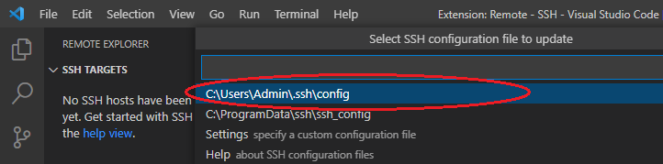
6. Edit the config file so it looks like the following (feel free to use a different “Host”, but HostName and User should be the same as this screenshot):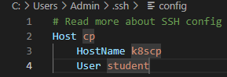
7. Add another entry for the worker node:

Host worker

HostName worker

User student

1. Save your changes
2. Right-click on “cp” in “Remote Explorer” and choose “connect to host in current window”: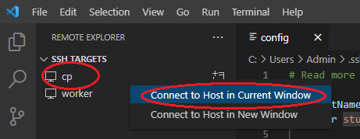
3. You’ll be presented with a Windows Defender dialog box. You need to allow access: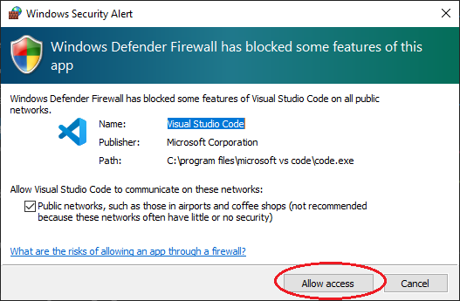
4. You’ll asked to select the platform of the remote host. It’s Linux: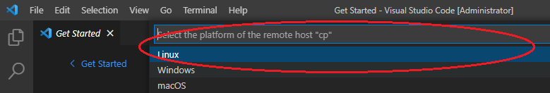
5. You’ll be asked to enter the password for the remotes host. It’s P@$$w0rd: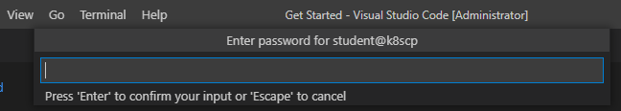
6. Next you’ll probably want to open your home directory on the VM: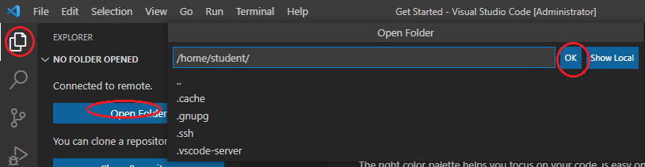
7. Which will mean you’ll need to provide your password again.
8. Yes you trust the authors!
9. And you’ll need to open another terminal: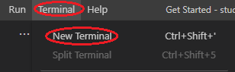
10. To create additional terminal windows, click on the plus button. You can even drag one of the terminals up into the edit pane so that you can see 2 terminals at once, which whilst not being as cool as **tmux**, is certainly a lot easier to get started with. You can also click on the “pages” icon to split vertically: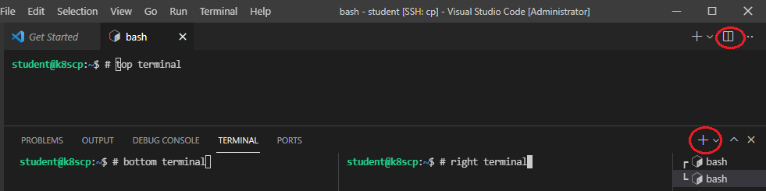
11. You will need to perform some tasks on the worker node, so fire up another copy of VSCode and follow the instructions from 9 onwards to connect to worker.